**How To Improve Supply Chains With Machine Learning**

<https://www.forbes.com/sites/louiscolumbus/2019/04/28/how-to-improve-supply-chains-with-machine-learning-10-proven-ways/#365966fe3f3c>

**Bottom line:** Enterprises are attaining double-digit improvements in forecast error rates, demand planning productivity, cost reductions and on-time shipments using machine learning today, revolutionizing supply chain management in the process.

Machine learning algorithms and the models they’re based on excel at finding anomalies, patterns and predictive insights in large data sets. Many supply chain challenges are time, cost and resource constraint-based, making machine learning an ideal technology to solve them. From [Amazon’s Kiva robotics relying on machine learning to improve accuracy, speed and scale](https://spectrum.ieee.org/automaton/robotics/industrial-robots/interview-brad-porter-vp-of-robotics-at-amazon) to [DHL relying on AI and machine learning to power their Predictive Network Management system](https://www.logistics.dhl/content/dam/dhl/global/core/documents/pdf/glo-artificial-intelligence-in-logistics-trend-report.pdf) that analyzes 58 different parameters of internal data to identify the top factors influencing shipment delays, machine learning is defining the next generation of supply chain management. [Gartner](https://www.gartner.com/) predicts that by 2020, [95% of Supply Chain Planning (SCP) vendors will be relying on supervised and unsupervised machine learning](https://www.gartner.com/document/3875876) in their solutions. [Gartner](https://www.gartner.com/) is also predicting by 2023 intelligent algorithms, and AI techniques will be an embedded or augmented component across[25% of all supply chain technology solutions](https://www.gartner.com/document/3873793).

The ten ways that machine learning is revolutionizing supply chain management include:

* **Machine learning-based algorithms are the foundation of the next generation of logistics technologies, with the most significant gains being made with advanced resource scheduling systems.** Machine learning and AI-based techniques are the foundation of a broad spectrum of next-generation logistics and supply chain technologies now under development. The most significant gains are being made where machine learning can contribute to solving complex constraint, cost and delivery problems companies face today. McKinsey predicts machine learning’s most significant contributions will be in providing supply chain operators with more significant insights into how supply chain performance can be improved, anticipating anomalies in logistics costs and performance before they occur. Machine learning is also providing insights into where automation can deliver the most significant scale advantages. Source: McKinsey & Company, [Automation in logistics: Big opportunity, bigger uncertainty](https://www.mckinsey.com/industries/travel-transport-and-logistics/our-insights/automation-in-logistics-big-opportunity-bigger-uncertainty), April 2019. By Ashutosh Dekhne, Greg Hastings, John Murnane, and Florian Neuhaus

[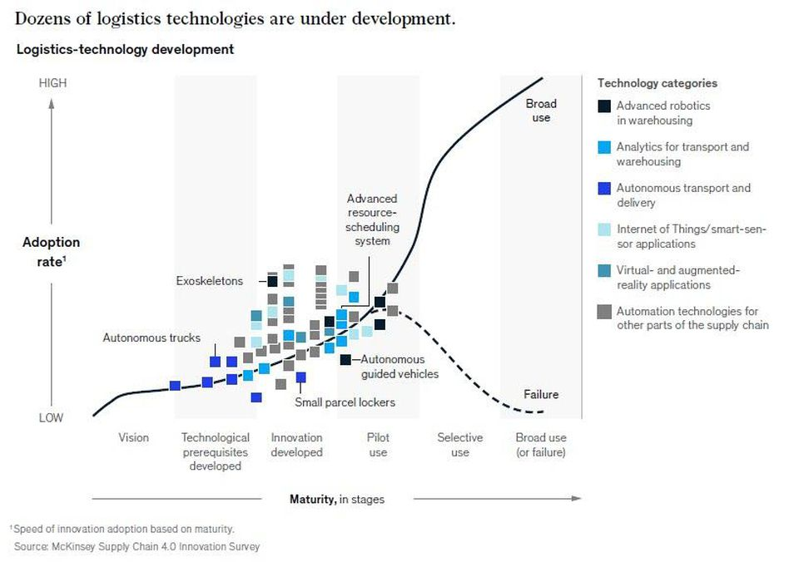](https://blogs-images.forbes.com/louiscolumbus/files/2019/04/Dozens-of-logistics-technologies-are-under-development.jpg)

SOURCE: MCKINSEY & COMPANY, AUTOMATION IN LOGISTICS: BIG OPPORTUNITY, BIGGER UNCERTAINTY, APRIL 2019. BY ASHUTOSH DEKHNE, GREG HASTINGS, JOHN MURNANE, AND FLORIAN NEUHAUS

* **The wide variation in data sets generated from the Internet of Things (IoT) sensors, telematics, intelligent transport systems, and traffic data have the potential to deliver the most value to improving supply chains by using machine learning.**Applying machine learning algorithms and techniques to improve supply chains starts with data sets that have the greatest variety and variability in them. The most challenging issues supply chains face are often found in optimizing logistics, so materials needed to complete a production run arrive on time. Source: [KPMG, Supply Chain Big Data Series Part 1](https://advisory.kpmg.us/content/dam/advisory/en/insights/pdfs/2018/supply-chain-big-data-part-1-shaping-tomorrow.pdf)

[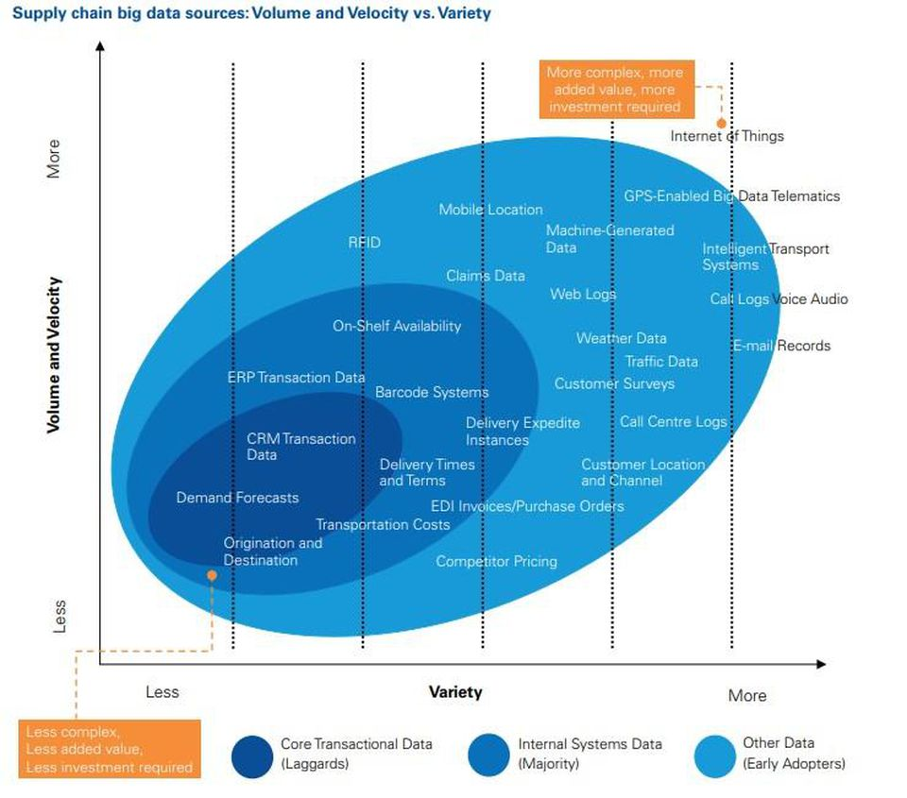](https://blogs-images.forbes.com/louiscolumbus/files/2019/04/Supply-chain-data-sources.jpg)

SOURCE: KPMG, SUPPLY CHAIN BIG DATA SERIES PART 1

* **Machine learning shows the potential to reduce logistics costs by finding patterns in track-and-trace data captured using IoT-enabled sensors, contributing to $6M in annual savings.** BCG recently looked at how a decentralized supply chain using track-and-trace applications could improve performance and reduce costs. They found that in a 30-node configuration when blockchain is used to share data in real-time across a supplier network, combined with better analytics insight, cost savings of $6M a year is achievable. Source: Boston Consulting Group, [Pairing Blockchain with IoT to Cut Supply Chain Costs](https://www.bcg.com/publications/2018/pairing-blockchain-with-iot-to-cut-supply-chain-costs.aspx), December 18, 2018, by Zia Yusuf, Akash Bhatia, Usama Gill, Maciej Kranz, Michelle Fleury, and Anoop Nannra

[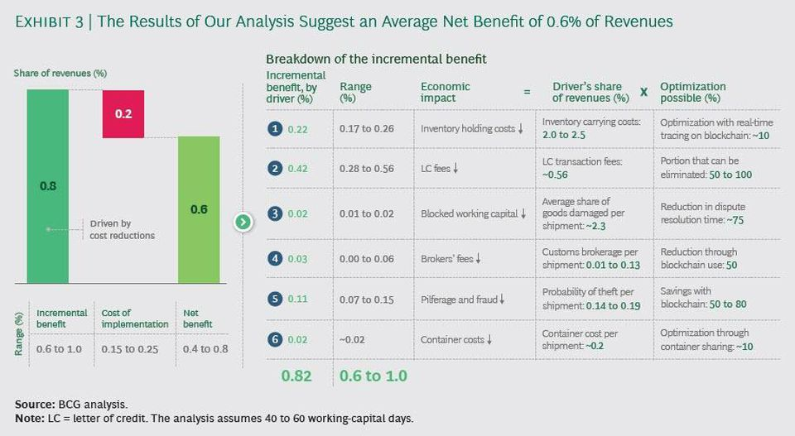](https://blogs-images.forbes.com/louiscolumbus/files/2019/04/BCG-Net-Benefits.jpg)

BOSTON CONSULTING GROUP, PAIRING BLOCKCHAIN WITH IOT TO CUT SUPPLY CHAIN COSTS, DECEMBER 18, 2018, BY ZIA YUSUF , AKASH BHATIA , USAMA GILL , MACIEJ KRANZ, MICHELLE FLEURY, AND ANOOP NANNRA

* **Reducing forecast errors up to 50% is achievable using machine learning-based techniques.**Lost sales due to products not being available are being reduced up to 65% through the use of machine learning-based planning and optimization techniques. Inventory reductions of 20 to 50% are also being achieved today when machine learning-based supply chain management systems are used. Source: Digital/McKinsey, [Smartening up with Artificial Intelligence (AI) - What’s in it for Germany and its Industrial Sector?](https://www.mckinsey.com/~/media/McKinsey/Industries/Semiconductors/Our%20Insights/Smartening%20up%20with%20artificial%20intelligence/Smartening-up-with-artificial-intelligence.ashx) (PDF, 52 pp., no opt-in).

[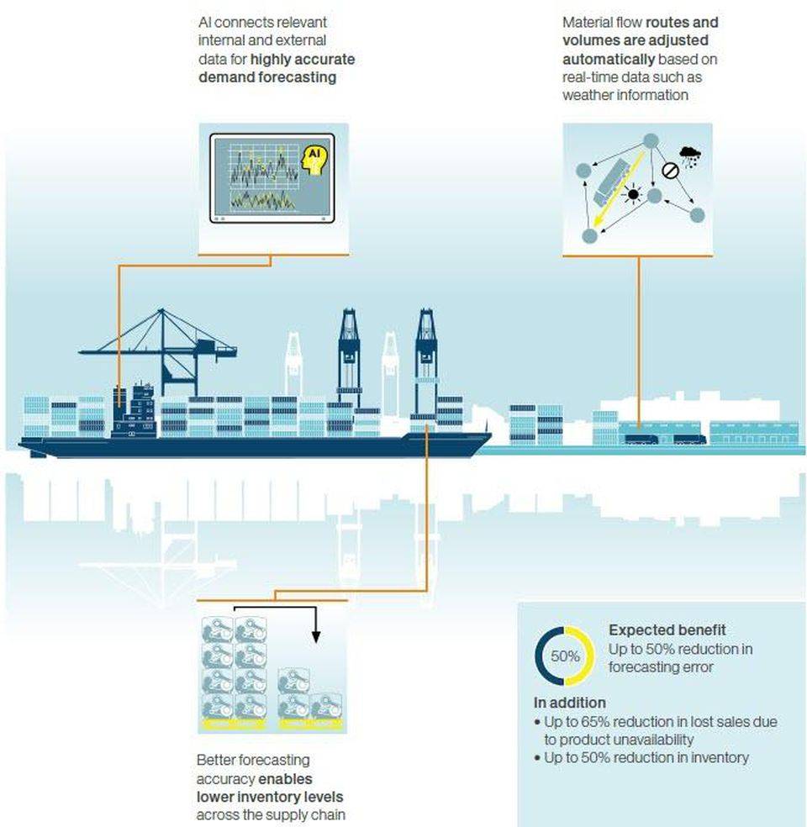](https://blogs-images.forbes.com/louiscolumbus/files/2019/04/Digital-McKinsey.jpg)

SOURCE: DIGITAL/MCKINSEY, SMARTENING UP WITH ARTIFICIAL INTELLIGENCE (AI) - WHAT’S IN IT FOR GERMANY AND ITS INDUSTRIAL SECTOR? (PDF, 52 PP., NO OPT-IN).

* **DHL Research is finding that machine learning enables logistics and supply chain operations to optimize capacity utilization, improve customer experience, reduce risk, and create new business models.** DHL’s research team continually tracks and evaluates the impact of emerging technologies on logistics and supply chain performance. They’re also predicting that AI will enable back-office automation, predictive operations, intelligent logistics assets, and new customer experience models. Source: DHL Trend Research, [Logistics Trend Radar, Version 2018/2019](https://www.logistics.dhl/content/dam/dhl/global/core/documents/pdf/glo-core-trend-radar-widescreen.pdf) (PDF, 55 pp., no opt-in)

[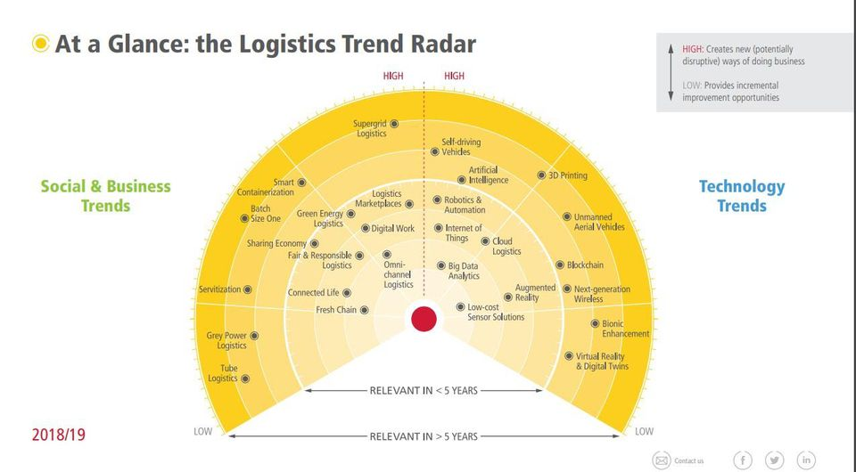](https://blogs-images.forbes.com/louiscolumbus/files/2019/04/Logistics-Trends-Radar.jpg)

SOURCE: DHL TREND RESEARCH, LOGISTICS TREND RADAR, VERSION 2018/2019 (PDF, 55 PP., NO OPT-IN)

* **Detecting and acting on inconsistent supplier quality levels and deliveries using machine learning-based applications is an area manufacturers are investing in today.** Based on conversations with North American-based mid-tier manufacturers, the second most significant growth barrier they’re facing today is suppliers’ lack of consistent quality and delivery performance. The greatest growth barrier is the lack of skilled labor available. Using machine learning and advanced analytics manufacturers can discover quickly who their best and worst suppliers are, and which production centers are most accurate in catching errors. Manufacturers are using dashboards much like the one below for applying machine learning to supplier quality, delivery and consistency challenges. Source: Microsoft, [Supplier Quality Analysis sample for Power BI: Take a tour](https://docs.microsoft.com/en-us/power-bi/sample-supplier-quality), 2018

[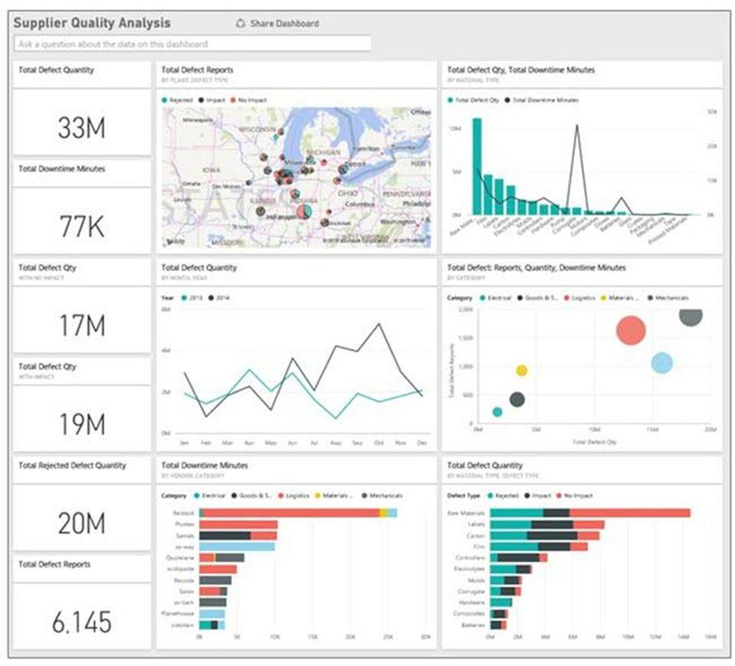](https://blogs-images.forbes.com/louiscolumbus/files/2019/04/Supplier-Quality-Analysis-Final.jpg)

SOURCE: MICROSOFT, SUPPLIER QUALITY ANALYSIS SAMPLE FOR POWER BI: TAKE A TOUR, 2018

* **Reducing risk and the potential for fraud, while improving the product and process quality based on insights gained from machine learning is forcing inspection’s inflection point across supply chains today.** When inspections are automated using mobile technologies and results are uploaded in real-time to a secure cloud-based platform, machine learning algorithms can deliver insights that immediately reduce risks and the potential for fraud. [Inspectorio](https://www.inspectorio.com/" \t "_blank) is a machine learning startup to watch in this area. They’re tackling the many problems that a lack of inspection and supply chain visibility creates, focusing on how they can solve them immediately for brands and retailers. The graphic below explains their platform. Source: Forbes, [How Machine Learning Improves Manufacturing Inspections, Product Quality & Supply Chain Visibility,](https://www.forbes.com/sites/louiscolumbus/2019/01/23/how-machine-learning-improves-manufacturing-inspections-product-quality-supply-chain-visibility/#2f26ef644397) January 23, 2019

[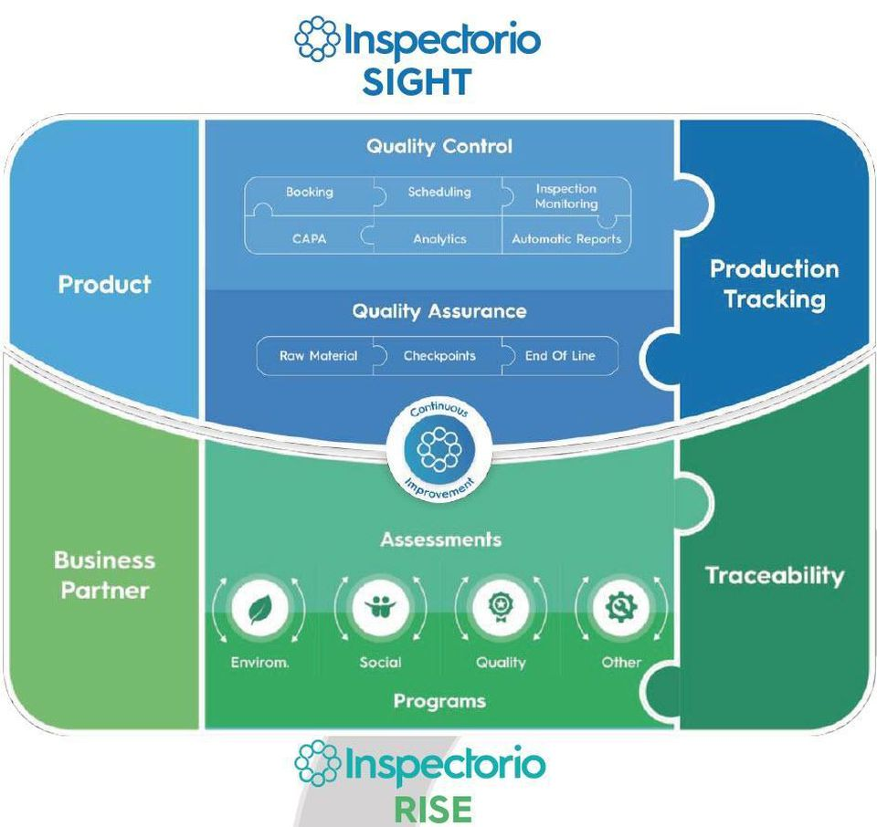](https://blogs-images.forbes.com/louiscolumbus/files/2019/04/Inspectario.jpg)

SOURCE: FORBES, HOW MACHINE LEARNING IMPROVES MANUFACTURING INSPECTIONS, PRODUCT QUALITY & SUPPLY CHAIN VISIBILITY, JANUARY 23, 2019

* **Machine learning is making rapid gains in end-to-end supply chain visibility possible, providing predictive and prescriptive insights that are helping companies react faster than before.** Combining multi-enterprise commerce networks for global trade and supply chain management with AI and machine learning platforms are revolutionizing supply chain end-to-end visibility. One of the early leaders in this area is [Infor’s Control Center](https://www.infor.com/products/supply-chain-management). Control Center combines data from the Infor GT Nexus Commerce Network, acquired by the company in September 2015, with [Infor’s Coleman Artificial Intelligence (AI)](https://www.infor.com/products/coleman) Infor chose to name their AI platform after the inspiring physicist and mathematician [Katherine Coleman Johnson](https://www.nasa.gov/content/katherine-johnson-biography), whose trail-blazing work helped NASA land on the moon. Be sure to pick up a copy of the book and see the movie [Hidden Figures](http://www.hiddenfigures.com/) if you haven’t already to appreciate her and many other brilliant women mathematicians’ many contributions to space exploration. [ChainLink Research](http://www.clresearch.com/home/" \t "_blank) provides an overview of Control Center in their article, [How Infor is Helping to Realize Human Potential](http://www.clresearch.com/research/detail.cfm?guid=B840D7DB-3048-78A9-2FB3-4F86A2A2337A), and two screens from Control Center are shown below.

[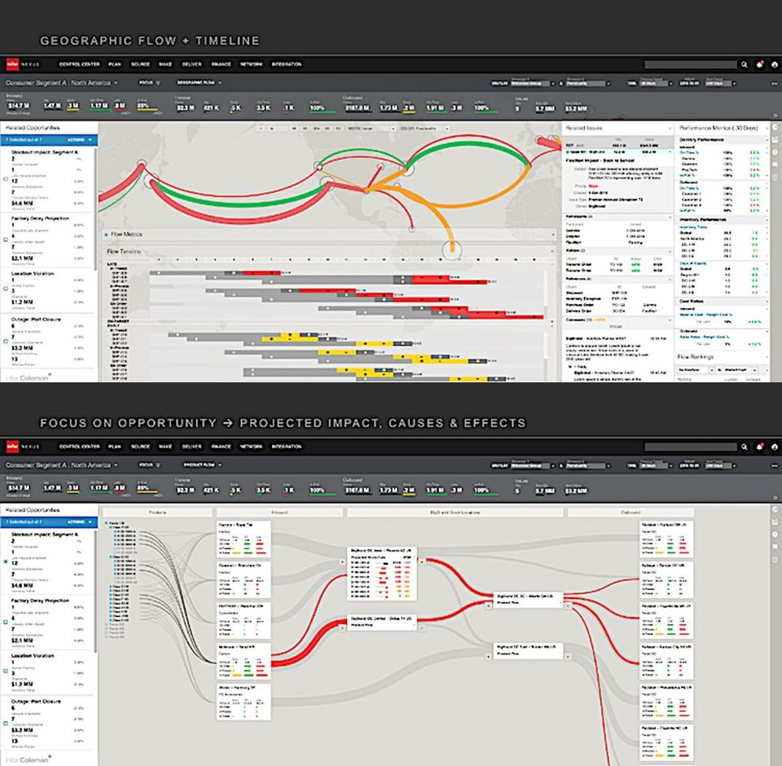](https://blogs-images.forbes.com/louiscolumbus/files/2019/04/Infor-Control-Center.jpg)

CHAINLINK RESEARCH, HOW INFOR IS HELPING TO REALIZE HUMAN POTENTIAL,

* **Machine learning is proving to be foundational for thwarting privileged credential abuse which is the leading cause of security breaches across global supply chains.**By taking a least privilege access approach, organizations can minimize attack surfaces, improve audit and compliance visibility, and reduce risk, complexity, and the costs of operating a modern, hybrid enterprise. CIOs are solving the paradox of privileged credential abuse in their supply chains by knowing that even if a privileged user has entered the right credentials but the request comes in with risky context, then stronger verification is needed to permit access.  [Zero Trust Privilege](https://www.centrify.com/education/what-is-zero-trust-privilege/) is emerging as a proven framework for thwarting privileged credential abuse by verifying who is requesting access, the context of the request, and the risk of the access environment.  [Centrify](https://www.centrify.com/) is a leader in this area, with globally-recognized suppliers including Cisco, Intel, Microsoft, and Salesforce being current customers.  Source: Forbes, [High-Tech's Greatest Challenge Will Be Securing Supply Chains In 2019](https://www.forbes.com/sites/louiscolumbus/2018/11/28/high-techs-greatest-challenge-will-be-securing-supply-chains-in-2019/#45eb9a275c84), November 28, 2018
* **Capitalizing on machine learning to predict preventative maintenance for freight and logistics machinery based on IoT data is improving asset utilization and reducing operating costs.** McKinsey found that predictive maintenance enhanced by machine learning allows for better prediction and avoidance of machine failure by combining data from the advanced Internet of Things (IoT) sensors and maintenance logs as well as external sources. Asset productivity increases of up to 20% are possible and overall maintenance costs may be reduced by up to 10%. Source: Digital/McKinsey, [Smartening up with Artificial Intelligence (AI) - What’s in it for Germany and its Industrial Sector?](https://www.mckinsey.com/~/media/McKinsey/Industries/Semiconductors/Our%20Insights/Smartening%20up%20with%20artificial%20intelligence/Smartening-up-with-artificial-intelligence.ashx) (PDF, 52 pp., no opt-in).

**References**

Accenture, [Reinventing The Supply Chain With AI](https://www.accenture.com/_acnmedia/PDF-82/Accenture-Intelligent-Supply-Chain-Management.pdf), 20 pp., PDF, no opt-in.

Bendoly, E. (2016). Fit, Bias, and Enacted Sensemaking in Data Visualization: Frameworks for Continuous Development in Operations and Supply Chain Management Analytics. *Journal Of Business Logistics*, *37*(1), 6-17.

Boston Consulting Group, [Pairing Blockchain with IoT to Cut Supply Chain Costs](https://www.bcg.com/publications/2018/pairing-blockchain-with-iot-to-cut-supply-chain-costs.aspx), December 18, 2018, by Zia Yusuf, Akash Bhatia, Usama Gill, Maciej Kranz, Michelle Fleury, and Anoop Nannra

Capgemini, [Supply Chain Management – The Quiet Revolution](https://www.capgemini.com/2019/04/supply-chain-management-the-quiet-revolution/). April 24, 2019

CB Insights, [Stocked Up: 150+ Companies Attacking The Supply Chain & Logistics Space](https://app.cbinsights.com/research/supply-chain-logistics-tech-infographic/), November 30, 2016

Chen, D. Q., Preston, D. S., & Swink, M. (2015). How the Use of Big Data Analytics Affects Value Creation in Supply Chain Management. *Journal Of Management Information Systems*, *32*(4), 4-39.

Council of Supply Chain Management Professionals (CSCMP) Supply Chain Quarterly, [Machine learning: A new tool for better forecasting](http://www.supplychainquarterly.com/topics/Technology/20141230-machine-learning-a-new-tool-for-better-forecasting/), Joseph Shamir, Q4, 2014

Council of Supply Chain Management Professionals (CSCMP) Supply Chain Quarterly, [Paving the way for AI in the warehouse](http://www.supplychainquarterly.com/topics/Technology/20180227-paving-the-way-for-ai-in-the-warehouse/), Luke Waltz   [Quarter 1 2018](http://www.supplychainquarterly.com/archives/2018/01/) issue

DHL, [Artificial Intelligence in Logistics, 2018](https://www.logistics.dhl/content/dam/dhl/global/core/documents/pdf/glo-artificial-intelligence-in-logistics-trend-report.pdf) (PDF, 45 pp., no opt-in)

DHL, [Cracking Logistics with the help of Machine Learning](https://rctom.hbs.org/submission/dhl-cracking-logistics-with-the-help-of-machine-learning/), Harvard Business School, November 13, 2018

DHL, [Logistics Trend Radar, 2016](http://www.dhl.com/content/dam/downloads/g0/about_us/logistics_insights/dhl_logistics_trend_radar_2016.pdf) (PDF, 55 pp., no opt-in)

DHL Trend Research, [Artificial Intelligence in Logistics, 2018](https://www.logistics.dhl/content/dam/dhl/global/core/documents/pdf/glo-artificial-intelligence-in-logistics-trend-report.pdf) (PDF, 45 pp., no opt-in)

DHL Trend Research, [Logistics Trend Radar, Version 2018/2019](https://www.logistics.dhl/content/dam/dhl/global/core/documents/pdf/glo-core-trend-radar-widescreen.pdf) (PDF, 55 pp., no opt-in)

Digital/McKinsey, [Smartening up with Artificial Intelligence (AI) - What’s in it for Germany and its Industrial Sector?](https://www.mckinsey.com/~/media/McKinsey/Industries/Semiconductors/Our%20Insights/Smartening%20up%20with%20artificial%20intelligence/Smartening-up-with-artificial-intelligence.ashx) (PDF, 52 pp., no opt-in)

Feizabadi, J., & Shrivastava, A. (2018). Does AI-enabled demand forecasting improve supply chain efficiency?*Supply Chain Management Review, 22*(6), 8-10.

Gartner, [Supply Chain Trends in the Digital Age,](https://www.researchgate.net/profile/Mohamed_Mourad_Lafifi/post/Supply_Chain_Trends_in_the_Digital_Age/attachment/5b5b64f74cde265cb6520913/AS%3A653073563262977%401532716279520/download/Supply+Chain+Trends+in+the+Digital+Age.pdf) February 17, 2016 (PDF, 9 pp., no opt-in)

Govindan, K., Cheng, T., Mishra, N., & Shukla, N. (2018). Big data analytics and application for logistics and supply chain management. *Transportation Research: Part E*, *114*343-349.

Hahn, G. J., & Packowski, J. (2015). A perspective on applications of in-memory analytics in supply chain management. *Decision Support Systems*, *76*45-52.

IDC, [Digital Transformation Drives Supply Chain Restructuring Imperative](https://www.opentext.com/file_source/OpenText/en_US/PDF/opentext-idc-digital-transformation-supply-chain.pdf), July 2017

IDC, [Overcoming Supply Chain Complexity with Predictive Logistics](https://landing.clearmetal.com/hubfs/Downloads%20-%20Whitepapers/IDC%20Predictive%20Intelligence.pdf), August 2017 (PDF, 8 pp., no opt-in)

Jayant, A. (2013). Evaluation of 3PL Service Provider in Supply Chain Management: An Analytic Network Process Approach. *International Journal Of Business Insights & Transformation*, *6*(2), 78-82.

KPMG, [Supply Chain Big Data Series, Part 2](https://advisory.kpmg.us/content/dam/advisory/en/insights/pdfs/2018/supply-chain-big-data-part-2-tools-platforms.pdf). June 2018 (PDF, 14 pp., no opt-in)

Lai, Y., Sun, H., & Ren, J. (2018). Understanding the determinants of big data analytics (BDA) adoption in logistics and supply chain management. *International Journal Of Logistics Management*, *29*(2), 676-703.

Mackelprang, A. W., Robinson, J. L., Bernardes, E., & Webb, G. S. (2014). The Relationship Between Strategic Supply Chain Integration and Performance: A Meta-Analytic Evaluation and Implications for Supply Chain Management Research. *Journal Of Business Logistics*, *35*(1), 71-96.

McKinsey & Company, [Automation in logistics: Big opportunity, bigger uncertainty](https://www.mckinsey.com/industries/travel-transport-and-logistics/our-insights/automation-in-logistics-big-opportunity-bigger-uncertainty), April 2019. By Ashutosh Dekhne, Greg Hastings, John Murnane, and Florian Neuhaus

McKinsey & Company, [Digital supply chains: Do you have the skills to run them?,](https://www.mckinsey.com/business-functions/operations/our-insights/digital-supply-chains-do-you-have-the-skills-to-run-them) July 2017.

Digital/McKinsey, [Smartening up with Artificial Intelligence (AI) - What’s in it for Germany and its Industrial Sector?](https://www.mckinsey.com/~/media/McKinsey/Industries/Semiconductors/Our%20Insights/Smartening%20up%20with%20artificial%20intelligence/Smartening-up-with-artificial-intelligence.ashx) (PDF, 52 pp., no opt-in)

McKinsey & Company, [Notes from the AI frontier: Modeling the impact of AI on the world economy](https://www.mckinsey.com/featured-insights/artificial-intelligence/notes-from-the-ai-frontier-modeling-the-impact-of-ai-on-the-world-economy), September 2018 By Jacques Bughin, Jeongmin Seong, James Manyika, Michael Chui, and Raoul Joshi

Papadopoulos, T., Gunasekaran, A., Dubey, R., & Fosso Wamba, S. (2017). Big data and analytics in operations and supply chain management: managerial aspects and practical challenges. *Production Planning & Control*, *28*(11/12), 873-876.

Schoenherr, T., & Speier-Pero, C. (2015). Data Science, Predictive Analytics, and Big Data in Supply Chain Management: Current State and Future Potential. *Journal Of Business Logistics*, *36*(1), 120-132.

Sharma, V. (2018). Demand forecasting in the cloud: Modern computing meets the forecasting discipline.*The Journal of Business Forecasting, 37*(3), 4-7,9-10.

Stanford University, Department of Management Science and Engineering,[Lectures in Supply-Chain Optimization](https://web.stanford.edu/group/msande-history/wikiupload/8/84/Veinott_Supply_Chain_Optimization_Course_Notes.pdf) (PDF, 261 pp., no opt-in)

Tata Consulting Services, [Using Machine Learning to Transform Supply Chain](https://www.tcs.com/content/dam/tcs/pdf/Services/BPS/Using%20Machine%20Learning%20to%20Transform%20Supply%20Chain%20Management.pdf) [Management](https://www.tcs.com/content/dam/tcs/pdf/Services/BPS/Using%20Machine%20Learning%20to%20Transform%20Supply%20Chain%20Management.pdf)

The Hackett Group, [Analytics: Laying the Foundation for Supply Chain Digital Transformation](https://www.thehackettgroup.com/wp-content/uploads/2017/12/hackett-analytics-supply-chain-digital-1711.pdf) (PDF, 10 pp., no opt-in)

Tiwari, S., Wee, H., & Daryanto, Y. (2018). Big data analytics in supply chain management between 2010 and 2016: Insights to industries. *Computers & Industrial Engineering*, *115*319-330.

World Economic Forum, [Impact of the Fourth Industrial Revolution on Supply Chains](http://www3.weforum.org/docs/WEF_Impact_of_the_Fourth_Industrial_Revolution_on_Supply_Chains_.pdf) (PDF, 22 pgs., no opt-in)

World Economic Forum, [Supply Chain 4.0 Global Practices, and Lessons Learned for Latin America and the Caribbean](http://www3.weforum.org/docs/WEF_Supply_Chain_4.0_2019_Report.pdf) (PDF, 44 pp., no opt-in)